

Join Mr Oliver Warren and Mr Akash Mehta in theatre at Chelsea & Westminster Hospital for this AWR Course focussed on technique & procedure, patient selection & optimisation and the CAWR Service & MDT. We will be combining theory with live observed operating of two patients undergoing open

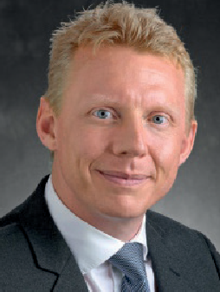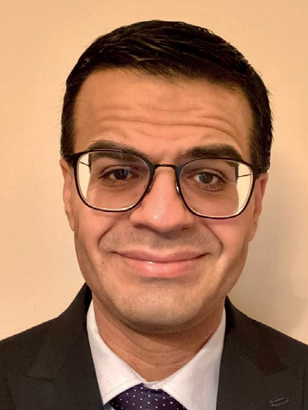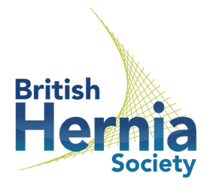

15TH & 16TH

November 2022

Mr Oliver Warren

Clinical Director of Surgery and a

Mr Akash Mehta

Consultant Colorectal Surgeon

at St Mark’s Hospital

and on the ACPGBI Abdominal Wall Subcommittee.

Consultant Colorectal and Hernia surgeon at

Chelsea and Westminster Hospital and on the BHS Abdominal Wall Subcommittee.

Northwest London Sector, St Mark’s & Chelsea & Westminster Hospitals

Complex Abdominal Wall Reconstruction Course

**OUR COURSE LEADERS**

**CPD ACCREDITED**

CAWR procedures simultaneously in neighbouring theatres.

**15/11/2022**

**5:30pm meet for lectures before dinner covering:**

Patient selection & optimisation: results of a Global Delphi Exercise

The role of the radiologist in the CAWR MDT MDT discussion of patients for surgery on 16/11 Dinner & overnight stay at central London Hotel

**16/11/2022**

**8am meet at Chelsea & Westminster Hospital**

Keynote lecture

CAWR Anatomy, Techniques and Outcomes Patient Story

Simultaneous observation of (minimum) 2 open CAWR cases with component separation

Session De-Brief and close 5pm



Scan the QR code to register your space [or visit: www.](http://www/)[qmedical.co.uk/register](http://qmedical.co.uk/register)

